Date: August 2023
To:
CC: Stated Clerks

Subject:
Dear Synodical Deputies and Synodical Deputy Alternates:
Summertime greetings! We hope that you are finding time to recharge and rejuvenate in preparation for the new “ministry year” ahead. Our current records indicate that you are serving as a synodical deputy or as alternate synodical deputy. If our records are incorrect, please take a moment to contact us with the correct information. Thank you!
One important item we’d like you to note is a new email address just for Synodical Deputies and alternates. We’re aware that it can be a lot to try and remember which CRCNA staff person to contact about which issues. So we’ve created a new email address that should simplify that, synodicaldeputyinfo@crcna.org. That address will be covered during all business days by one staff member or another, and will allow you to ask questions, contact us with travel issues, and submit reports all to one place.
The following is a list of resources for synodical deputies. Some are in the process of being updated, which is marked in parentheses. All of your resources (including the Church Order and Commissioned Pastors Handbook) are linked on the Synodical Deputies Resources page at crcna.org/SynodicalDeputies.
- Manual for Synodical Deputies - Please review the Manual for Synodical Deputies (2023 edition) whether you are new or continuing service as a synodical deputy or alternate or serve as stated clerk of classis. Highlighted text in the Manual for Synodical Deputies reflects sections that were updated from the previous 2022 version. We advise that you download or print a copy of the full revised 2023 Manual if you do not have web access during classis meetings. For new synodical deputies and stated clerks . . . a print out of the Manual for Synodical Deputies is available in a three-ring binder free of charge from the Synodical Services Office. Just send us a note (synodicaldeputyinfo@crcna.org) if you need a print version.
- Synodical Deputy Forms (major revisions expected) - The existing Synodical Deputy forms are proving to be cumbersome for our office, and we suspect for many of you as well. We are looking into extensive revisions of those forms, although we’ll continue to accept the current forms as well. We'll be looking for a few “guinea pigs” to test out the new forms before we roll them out to everyone.
- Expense Forms - The Synodical Services Office covers the cost of travel, meals, and lodging for synodical deputies or alternates for their service. Download the appropriate Canadian or U.S. expense form for reimbursement from the webpage for each meeting you attend (www.crcna.org/SynodicalDeputies). The Canadian form is updated monthly to reflect the current exchange rate.
- Synodical Deputies Travel Policy - For all other travel reimbursement questions, please refer to this travel policy. Remember that the CRCNA covers the least expensive means of travel (taking into account the nearest car rental agency). We have enclosed a helpful “Mileage Calculator Tool” for use.
- U.S. deputies need to contact our office prior to booking air travel (synodicaldeputyinfo@crcna.org) - see the important notice about this requirement in the Travel Policy in order to book through the CRCNA travel provider, FROSCH-Conlin Travel.
- Summary of Occasions When Synodical Deputies Are Needed - There are occasions when it is possible to do synodical deputy work by conference call or video conference rather than making a trip to a classis meeting for routine matters. Please recognize that, while we want to be good stewards of the time and money involved in traveling, and video conferencing is becoming more common, much of a synodical deputy’s work is still better done in person.
- Commissioned Pastor Handbook - offers a helpful guide to Church Order articles and synodical decisions regarding commissioned pastors (revisions currently in the synod Agenda Supplement, p. 835, a separate document will be released soon).
- Church Order (2022 available, revisions for 2023 coming) - You will receive a printed copy of the Church Order and Its Supplements 2023 as soon as it is available.
Note: Synod 2023 did not adopt any changes to the Church Order that directly affect synodical deputy work in the coming ministry year. However, it did propose two Church Order changes for adoption by Synod 2024 that may have minor impacts on synodical deputy work in the future. Particularly, Synod 2023 adopted the work of the Study of Bivocationality Task Force and it is worth noting the positive attitude adopted toward those pursuing bivocational ministry. Synod 2023 also proposed that Synod 2024 add language about the newly adopted Code of Conduct to the Church Order. This will not directly affect the work of synodical deputies, but will show up in some of the Church Order articles that require synodical deputy involvement.
As most of you realize, there is more to our Church Order than just rules on a page. We encourage you to make use of three valuable resources that can expand your understanding of the wisdom of our Church Order, how the rules came to be, and how we can best apply them:
- Manual of Christian Reformed Church Government (revision coming) - there is a free download available for each synodical deputy and alternate (notify our office if do not have this resource)
- Christian Reformed Church Order Commentary (Second Edition by Henry De Moor)
- Church Order Video Series - a series of Church Order videos produced by CRC polity professor, Kathy Smith. There is a one-time registration fee for accessing the videos—see the link for registration information.

We are grateful to each of you for the contributions and service you offer on behalf of synod. It is our hope and prayer that you will be blessed by your service as a synodical deputy or as a stated clerk during the coming year! Please feel free to contact me if you have any questions about these resources.

Yours in Christ,
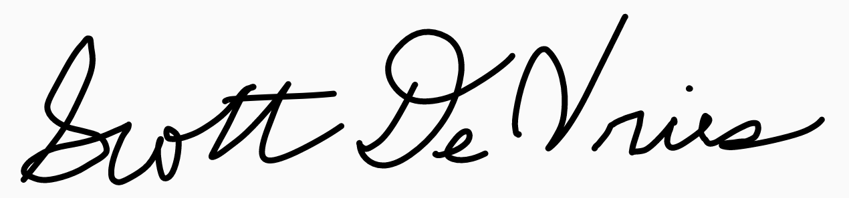
Scott DeVries
Director of Synodical Services

