SENIOR

Stories of
Hope
Accomplishments
Remembrance
Experiences

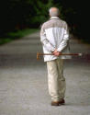

“Every person is an unfinished story… We dare to explore the unfinished story we continue to create until we draw our last breath.”
Paula Farrell Sullivan

About the facilitator:

Renee Roeschley is a certified Spiritual Director. She received her training through The Institute of Spiritual Companionship, an ecumenical program in Evanston, Illinois. She has a Bachelors Degree in Social Work and has worked primarily with older adults for more than 20 years. She lives on the Northwest side of Chicago with her husband Curt. Currently, she is a member of Grace Evangelical Covenant Church in Chicago where she and her family attend church and where she founded and co-leads a Senior Share group.

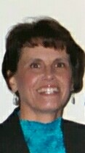

SENIOR SHARE

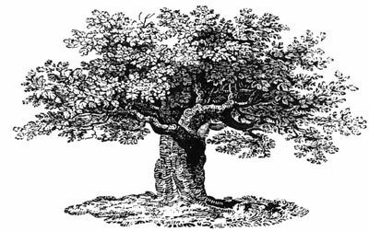

“Everyone has, or lives, or is, a story. In the life review the plot line is not always clear. There are many subplots, detours, and wildernesses in each journey. But connections are made; we can remember pieces of our lives.”
Roy W. Fairchild

Senior Share is a spiritual storytelling group where seniors

-come together to share life experiences and listen to others share

-discover how spirituality may have impacted life’s journey

-experience community where life review can bring understanding, healing, direction, and fellowship.

“Telling the story of our lives is one of the most important activities of the later years. It reminds us that we are still emerging, growing people. It shows us how we have changed and how we have been transformed.… (Life review) is . . . stabilization in the security of the past so that we can go beyond to embrace the future.”
Jane Marie Thibault

A Senior Share group runs for six to eight weeks and can be hosted by any church or organization. The host group may choose the location that is most convenient to the seniors participating.

The size of the group can range from six to ten participants and meets for 90 minutes per session. Materials are provided by the facilitator for each group. The fee is negotiated with each church or organization contracting.

For further information call:
(773) 319-2510
renee.roeschley@gmail.com

Mission Statement

To provide a nurturing environment for seniors where community is built through sharing life stories and discovering spiritual meaning in their journey.

Quotes from Senior Share group members about their experience of the group:

“To be able to exchange stories with my peers has filled the biggest void in my life since I retired.”

“I appreciate when people talk about their experiences in life and how they coped with difficult situations.”

“I liked the openness of the discussions and the lack of criticism.”

