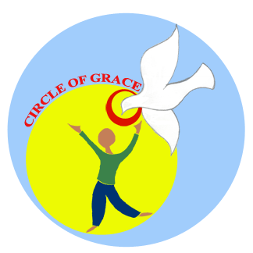
CIRCLE OF GRACE PROGRAM: ORDER FORM

Date of Order: ____________________________

Church Name: ____________________________________________________

Church Address: ____________________________________________________

____________________________________________________

Primary Circle of Grace Contact Person* & Title (or relationship to church if no title):

Name: ____________________________________________________

Title/Position: ____________________________________________________

Phone number: ____________________________________________________

Email address: ____________________________________________________

*This is the person responsible for overseeing the Circle of Grace program at your church.

By signing this order form, I acknowledge the following (please initial each statement):

_____ I agree to adhere to the CRC Safe Church Ministry copyright contract, which states that these materials will be used only for purposes and programs associated with
___________________________________________________ (name of church).

_____ I agree to use the materials in the intended manner and to follow program recommendations whenever possible.

_____ In accordance with program recommendations, training will be provided for all teachers using the Circle of Grace training materials (included in program).

_____ I agree to encourage the use of pre- and post- assessments in grades 3, 6, and 9; and to share the “summary evaluation” with Safe Church Ministry to aid in determining the effectiveness of the Circle of Grace program.

Following shipment of your order (please allow 1-3 weeks), an invoice will be sent in the amount of $25.00 US (CDN price at current exchange rate) plus shipping/handling and applicable sales tax.
Safe Church Ministry agrees to offer ongoing support in implementing the Circle of Grace program. Please contact us with any questions, comments, or concerns.

Contact: Bonnie Nicholas, Director
Safe Church Ministry, CRCNA
1700 28th St. SE, Grand Rapids, MI 49508
bnicholas@crcna.org or 616-224-0735

"They will live in safety and no one will make them afraid." Ezekiel 34:28

