To all whom it may concern
This is to certify that
____________________________________________________________
was examined by Classis Classis name here
of the Christian Reformed Church in North America, was declared qualified
for the office of minister of the Word, and was ordained as a minister of the Word.
on Month and Day, Year
in Name of Church, City, State/Province
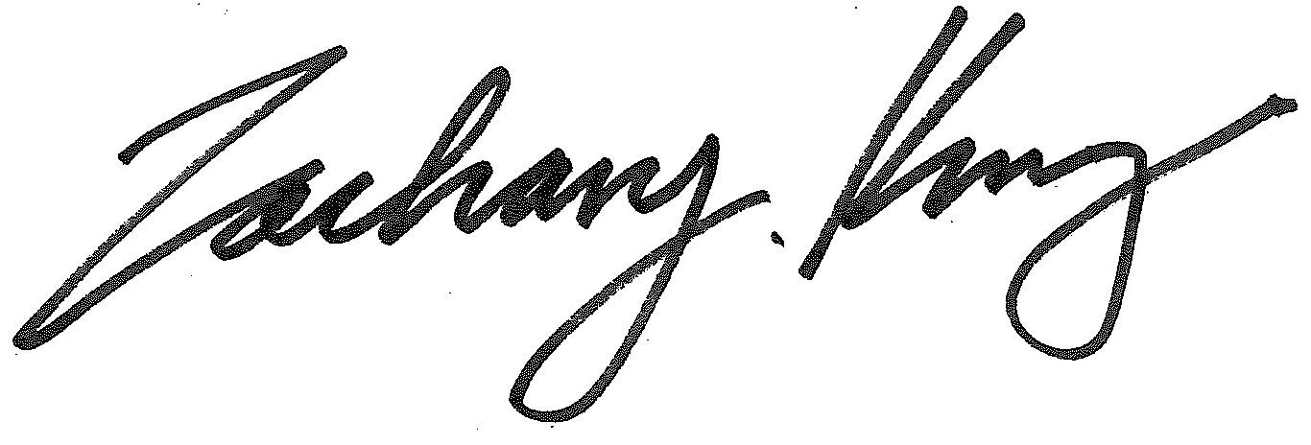
____________________________________________________________
General Secretary, Christian Reformed Church in North America

